**2022-CS-36**

**Task 1**

#include <iostream>

#include <thread>

#include <mutex>

using namespace std;

int globalVariable = 0;

int result = 0;

mutex mtx;

void threadFunction(int id)

 {

    for (int i = 0; i < 100000; ++i) {

        mtx.lock();

        globalVariable++;

        result += globalVariable;

        mtx.unlock();

    }

}

int main() {

    thread t1(threadFunction, 1);

    thread t2(threadFunction, 2);

    thread t3(threadFunction, 3);

    t1.join();

    t2.join();

    t3.join();

    cout << "Final value of globalVariable: " << globalVariable << endl;

    cout << "Final value of result: " << result << endl;

    return 0;

}

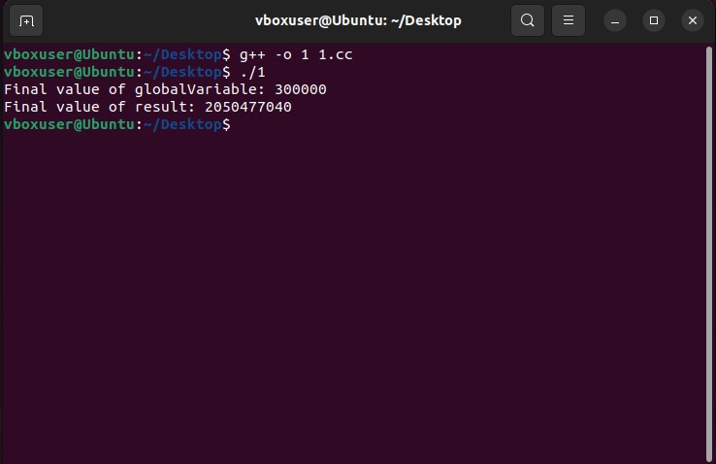

**Task 2:**

#include <iostream>

#include <pthread.h>

using namespace std;

void *print(void *arg)

{

    pthread_t id = pthread_self();

    cout << "Hello, I am thread " << *((int *)arg) << " my ID is " << id << endl;

    pthread_exit(NULL);

}

int main()

{

    int numThreads;

    cout << "Enter the number of threads to create: ";

    cin >> numThreads;

    pthread_t threads[numThreads];

    int threadArgs[numThreads];

    for (int i = 0; i < numThreads; ++i)

    {

        threadArgs[i] = i + 1;

        pthread_create(&threads[i], NULL, print, (void *)&threadArgs[i]);

    }

    for (int i = 0; i < numThreads; ++i)

    {

        pthread_join(threads[i], NULL);

    }

    exit(0);

}

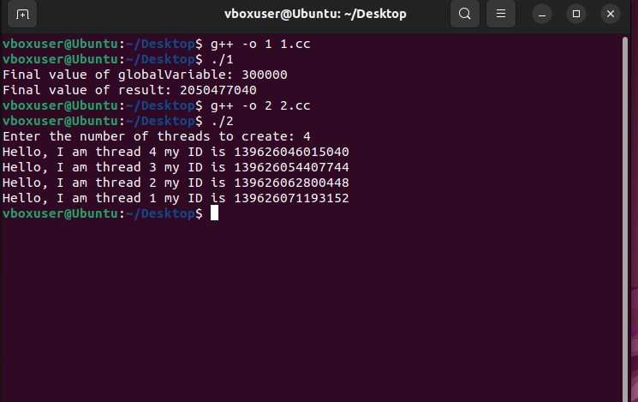

**Task3:**

#include <iostream>

#include <pthread.h>

using namespace std;

void *task1(void *)

{

    cout << "Thread 1: Performing task 1" << endl;

    pthread_exit(NULL);

}

void *task2(void *)

{

    cout << "Thread 2: Performing task 2" << endl;

    pthread_exit(NULL);

}

void *task3(void *)

{

    cout << "Thread 3: Performing task 3" << endl;

    pthread_exit(NULL);

}

void *task4(void *)

{

    cout << "Thread 4: Performing task 4" << endl;

    pthread_exit(NULL);

}

int main()

{

    pthread_t thread1, thread2, thread3, thread4;

    pthread_create(&thread1, NULL, task1, NULL);

    pthread_create(&thread2, NULL, task2, NULL);

    pthread_create(&thread3, NULL, task3, NULL);

    pthread_create(&thread4, NULL, task4, NULL);

    pthread_join(thread1, NULL);

    pthread_join(thread2, NULL);

    pthread_join(thread3, NULL);

    pthread_join(thread4, NULL);

    cout << "All threads have finished their tasks." << endl;

    return 0;

}

**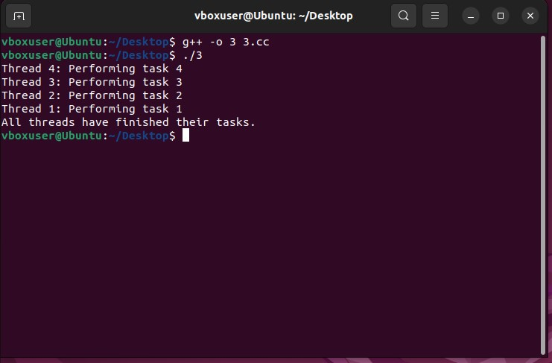  
  
Task4:**

#include <iostream>

#include <pthread.h>

#include <unistd.h>

using namespace std;

void *threadFunction(void *arg)

{

    long thread_id = (long)arg;

    pid_t process_id = getpid();

    cout << "Thread " << thread_id << ": Thread ID: " << pthread_self()<< ", Process ID: " << process_id << endl;

    pthread_exit(NULL);

}

int main()

{

    const int numThreads = 4;

    pthread_t threads[numThreads];

    for (long i = 0; i < numThreads; ++i)

    {

        pthread_create(&threads[i], NULL, threadFunction, (void *)i);

    }

    for (int i = 0; i < numThreads; ++i)

    {

        pthread_join(threads[i], NULL);

    }

    return 0;

}

